Hedgehog Class – Easter 2020

As the Easter holiday is about to begin, I have listed some websites and activities that you and your children may like to do over the Easter break. These are just ideas and suggestions and it is completely your choice whether you decide to use them or not.

Easter

Baker Ross - online craft materials for sale - lots of Easter craft ideas
Twinkl (if you can access they have an EYFS Easter Home Learning Activity Pack with lots of different ideas –
https://www.twinkl.co.uk/resource/t-t-2546901-eyfs-easter-home-learning-activity-pack
Please see our website for further Easter activities. Click on the heading News & Events.
Although some of these activities are aimed at older children, do scroll down for activities our Hedgehogs can take part in.

On-line safety

I am aware that you are being directed to lots of different websites and that children will be exploring on their devices at home. Unfortunately we are hearing on the news that some people are using this fact to target children. Please be aware of what your child is looking at and talk to them about what they should do if something pops up that they weren’t expecting. Smartie the Penguin helps to address this. Please click on the EYFS story.

Thinkuknow - Thinkuknow are releasing fortnightly home activity packs, the packs are age specific and each pack has two 15 minute activities. Please scroll down and you will find a link for Early Years resources.
Childnet website - Smartie the Penguin – KS1
Vodafone – have a good guide for parents to download
Child Online Safety website – Information for parents

English/Phonics

Early Years Maths and Phonics with Mrs P - some great YouTube videos to help with Reception Maths and Phonics home learning
https://www.bbc.co.uk/newsround/52031295 David Walliams – story a day
Online library resources – you should have received by email a link for a newsletter from the NCC Education Library Service containing information & links to resources. This has lots of ideas and websites to visit.
Mr Thorne does phonics/Geraldine Giraffe – video clips
Phonicsplay – phonics games
Letters and Sounds – phonic games and resources for reading

Maths Websites

Todo maths online
Topmarks – maths – this includes Daily 10 – mental maths challenge – decide on the level and how long your child has to answer!
White Rose Maths
https://www.youcubed.org/resource/youcubed-at-home/
You will have to type this in or go to Youcubed website

PSED (personal, social and emotional development)

This link contains a free book explaining Covid-19 and social distancing in a child friendly manner.
https://www.flipsnack.com/CSKidsBooks/what-s-going-on.html
So many children are feeling worried and anxious right now, this could help alleviate some of their fears and it has received some good feedback. Read through it first and see if you would like to share it with your child.

Music

Hedgehog Class love music and love to sing (and dance!) please do look at this website and explore the resources. Definitely go to the Out of the Ark section. We usually have to pay to access this resource!! They have some great songs and in keeping with our Easter theme – please go to KS1 Week 2 – Friday’s song - Spring Chicken!
https://www.norfolkmusichub.org.uk/site/about-the-hub/resources-for-schools/learning-resources/

PLEASE CONTINUE TO SCROLL DOWN …


It just remains for me to say I hope you have a very happy, peaceful and safe Easter and I look forward to being with you again on Monday 20th April 2020.

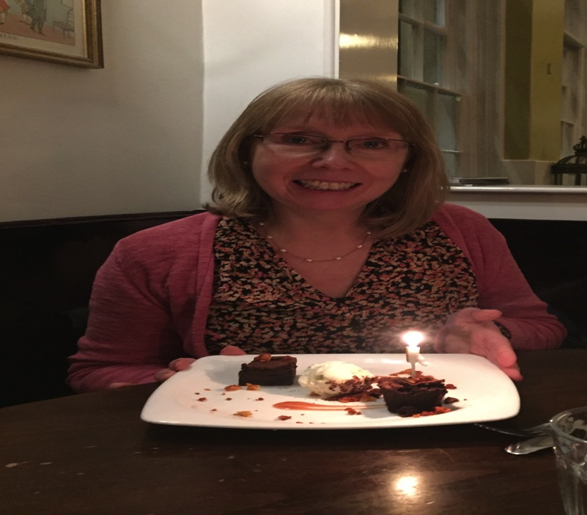
(photo taken before recent events!)

