Hedgehog Class Home Learning Tuesday 31st March 2020

English/Phonics

Tricky Word Songs Phase 3 and Phase 4 as a warm up
Phase 3 tricky words = you they, all are, my, her, he, she, we, me, be, was
Phase 4 tricky words = said, like, do, come, there, like, out, have, so, some, were, one, when, what
(if your child recognises the Phase 3 words please have a look at Phase 4)

Teach the tricky word ‘out’ if the children recognise the digraph ou they can sound talk this tricky word.
Say the word, look at the word, hide it around the house along with some, come, like, have, said, there.
Orally put into sentences ie I went out in the garden. The light went out in my bedroom.
Could they have a go at writing out maybe with a stick in soil, finger in sand or rice or flour …

sk/sc words
These two letters may sound like sg but explain that words don’t start with these two letters together.
Have a go at reading the following words

skip | scoop | skill | scarf
scab | skid | skin | scooter

Could they have a try at writing 3 of these words then putting one of the words into a sentence that they write i.e. I had a go on my scooter. I can skip. My scarf is red and green. If they want to write more then that is fine!

Maths

White Rose Maths Website
Week 1 – Easter Activities – unfortunately the link does not work but if you go to the website, home learning, early years or type the following in
https://whiterosemaths.com/homelearning/early-years/
then click on Week 1 – Starting with a story – Egg Hunt
You can then go to this website each day to continue with the theme of Easter Activities.
It will start with a short video then there is an activity.
You may pick and choose depending on how interested your child is.

If you would like to continue during the Easter holiday you can look at Week 2.
If your child would like more of a challenge – have a look at the Year One ideas.

Topic – Change

Following on from the life cycle of a frog – could the children think about the life cycle of a dinosaur? Can they order the pictures and talk about what happens during each stage? They may like to draw a picture of their favourite dinosaur and label it?
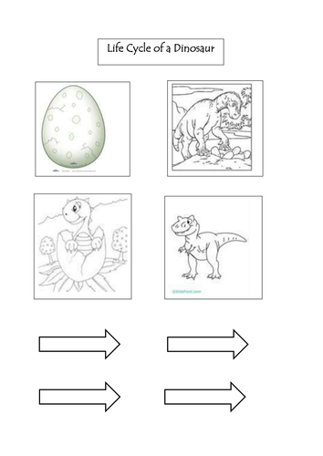
Collective Worship
https://www.youtube.com/watch?v=vScHI_fxJGM
The Last Supper Cartoon – please explain that the Easter Story is what Christian believe and please be aware that an advert may pop up during the story.

