Hedgehog Class Home Learning Friday 27th March 2020

English/Phonics

https://www.youtube.com/watch?v=Kotny7AO-VY
Mr Mc on youtube – Day 2 and the digraph is ‘or’

Possible follow up ideas –
Letter formation – try writing words that your grown up says in glitter/sand/
flour/sugar etc great to rub out when you have finished or if you make a mistake. Please remember to whoosh in and out though!
If you write the following words out and cut them up can your child read them and sort them into rhyming words?
Words = cord, fork, cork, horn, born, storm, short, thorn, corn, fort, torch, sport
Further extension: Can they choose some of these words to put into a sentence orally then have a go at writing them? I.e. There was rain in the storm. When it is dark I get a torch.
I have attached a little poster at the end of this plan.

Music
https://www.bbc.co.uk/teach/school-radio/nursery-rhymes-a-to-z-index/z4ddgwx
BBC Nursery Rhymes – the children love this website and take turns to choose their favourite songs. Maybe today they could design and make an instrument/instruments so that they can play along while they sing??? Will it be an instrument they blow, tap, shake …? https://www.bbc.co.uk/programmes/p05rf6b6
Can they make their sounds change?
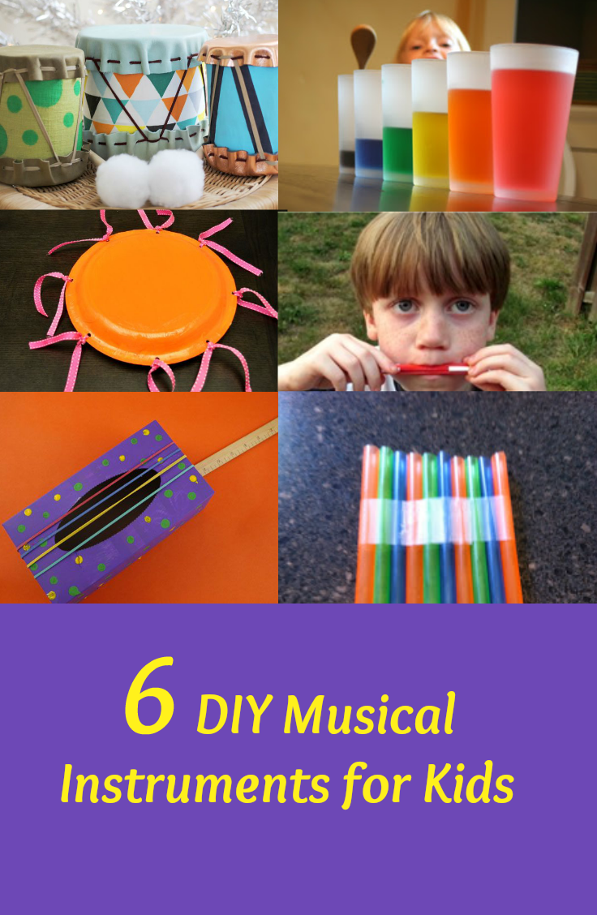
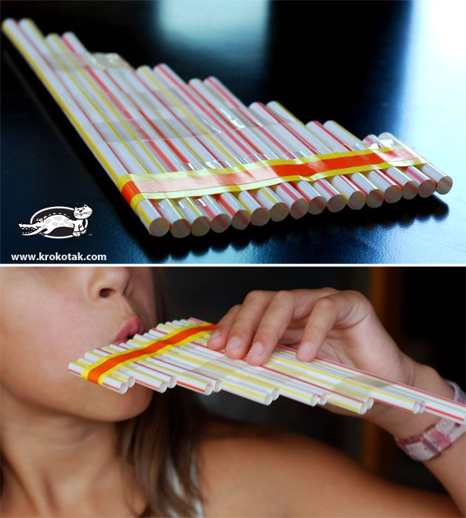

Collective Worship
https://www.bbc.co.uk/programmes/p05rf6b6 Our Senses – Sight

Maths

Thank you to all of you who sent me pictures of your amazing potions!



