Hedgehog Class Home Learning Wednesday 25th March 2020

English/Phonics

CGP Book – next 2 pages please

Phonic games – using Phonicsplay if you are able or games on Letters and Sounds website – Phase 3 http://www.letters-and-sounds.com/phase-3.html
Please recap digraph oa as in boat, coat, goat, float, moat, stoat
Can they put these words orally into a sentence? Can they make a silly sentence that they/you write? For example:
The goat in a coat sat on a boat that could float in the moat!

Maths

CGP Book – pages 3-5 (inclusive)
Extend at home using real objects ie lego pieces – put into two piles – which has more/fewer. How can you check?
Ordering numbers – again this can be done practically if you write the numbers on small pieces of paper and mix them up – your child then sorts them and puts them in the correct order.
Extension: numbers 10-20, 25-35 etc
When recording in the box on the bottom of page 5 to extend use number ideas above ie write numbers 25-35

Personal, Social and Emotional Development

We are all finding it strange not being able to mix and meet up with our friends but Logan has had a fantastic idea. He would like to send his friends a postcard each week. If your child writes/draws a postcard and you take a photo of them holding it (on Tapestry), I can have the picture up on my laptop and take a photo of it and send it via Tapestry. We could even still try Child of the Day and whoever it is can have their photo taken and I will send it to the rest of the class? All ideas greatly received!

Collective Worship (sorry for delay – problem with the links!)
https://www.bbc.co.uk/programmes/p05rf83h
https://www.bbc.co.uk/programmes/p05rf7fr

Speaking and Listening:
Please share the picture below with your child and talk about what they see and ask the questions below the picture. There are no right or wrong answers but they are getting used to answering questions and using inference.

FIRST FLIGHT
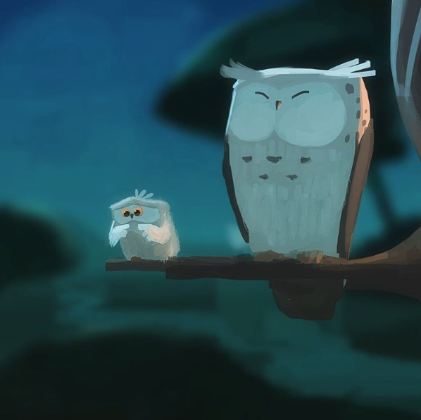
- How are the owls related?
- Which owl is about to take its first flight? How do you know?
- How does the young owl feel about flying?
- What might it be thinking? Add a thought bubble to the picture.
- Is the older owl worried?
- What advice might the older owl give to the younger one?
- Dictate ‘An Owl’s Guide to Flying’, to be used by younger owls before their first flight.
- Think of the first time you did something new. How did you feel about it? What emotional journey did you go on?
- If trying new things is scary, does that mean you should never try them?

