
Class 1 Summer Term Newsletter

Narborough Church of England Primary Academy April 2018

Welcome to the start of an exciting and busy Summer term! We hope you enjoyed the Easter break.

Topic - ‘Robots’.
This half term we will be thinking about Robots. This will include:
- investigating materials to see whether they are magnetic or not
- programming toys
- making robots as a homework activity linked to Show and Tell
- robot maths - function machines
- phonic games
If you have any robot books or anything that links with robots, we would love to see them.

In class we will be looking at No-Bot by Sue Hendra, Robots, Robots Everywhere by Sue Fliess, Harry and the Robots by Ian Whybrow and The Iron Man by Ted Hughes.

We will also be thinking about Spring as the children see the changes that are taking place in nature around them.

During the second half of the term our thoughts will turn towards the seaside and possibly pirates!

Ollie Orangutan
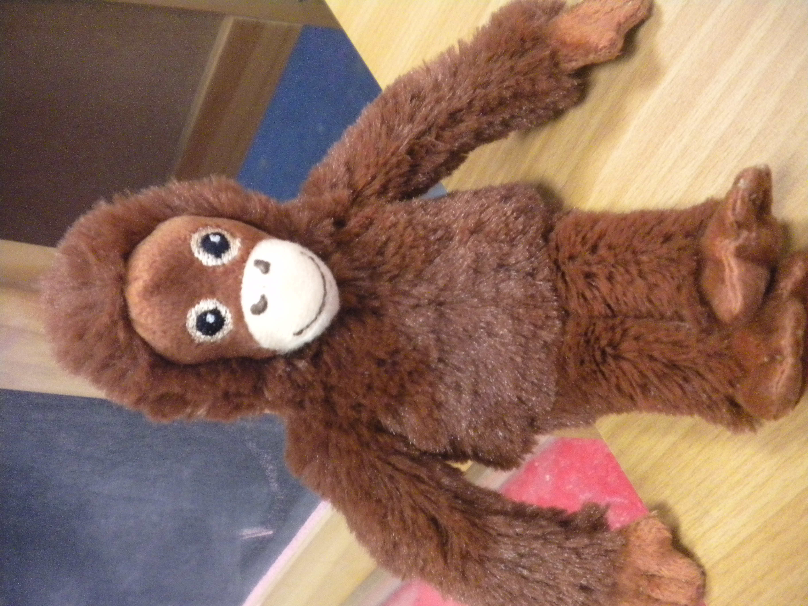
We would like to welcome Ollie to Class 1. He is a cuddly orangutan about the size of an adult’s hand and he would love to spend time with the children so he can explore the local area and maybe go further afield! If you were visiting a park or the beach Ollie would love to join you. If you are able to take photos they could go straight onto Tapestry. I will print any pictures to put in a class book and I would like to put some on our website page too. If the children were able to find out an interesting fact about the endangered orangutan, that would be fantastic and again I would share this information with the class.

Show and Tell – Friday
This half term for Show and Tell the children will be set a challenge to make a robot at home. The robot can be made from anything ie recycled materials, lego, card etc. For even more of a challenge, can you make a robot with moving parts? During Show and Tell the children will be encouraged to talk about how they made their robot and to use their imagination to talk about what they think it can do. Can it make rainbow coloured ice cream?

Dates for when your child will have the opportunity to show their robot:
Friday 27th April – Theo, Elsie, Jacob, Rosie
Friday 4th May - Esme, Macie, Jack, Oscar
Friday 11th May – Ida, Jenson, Keenan
Friday 18th May – Izabel, Jayden, Kai, Ashden
On Friday 25th May the children may bring something such as a toy in from home to show.

Library – books will be changed on Thursday.
Reading – books will be changed on Tuesday and Thursday. Please sign to show when you have shared a book with your child.
PE – this has changed and is now on a Thursday. Could your child’s indoor and outdoor PE kit please be left at school? We will send them home on Friday each week.

Transition
We have an exciting opportunity for the children in Reception to spend an hour each Friday morning with the Year One children in Class 2. This will allow them to become familiar with the class, teacher, children, learning and expectations for when they move in September. We are organising a parents’ transition meeting for Class 1 and 2 – date to be confirmed.

Finally, as always, please do not hesitate to contact us if you have any concerns or worries about your child.

Many thanks, Miss Taylor, Mrs Smith and Mrs Griffiths.

In Collective Worship, this half term’s value is Truthfulness.

Being RESPECTFUL Being RESPONSIBLE Being COURAGEOUS Being THANKFUL Being HOPEFUL

